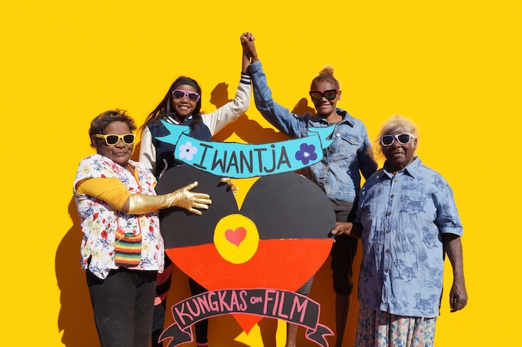

Aṉangu women artists celebrated in Kungka Kuṉpu (Strong Women) at [VENUE]

‘The Seven Sisters story has always been important for Aṉangu women and it is
more important today than ever before…… This is the power of women leaders.
We can make all the women coming behind us fly.’ – Nyunmiti Burton

[VENUE], in partnership with the Art Gallery of South Australia’s acclaimed Tarnanthi program, will present an exhibition of major contemporary works by celebrated women artists from the Aṉangu Pitjantjatjara Yankunytjatjara (APY) Lands from [START DATE] to [END DATE].

Drawn from AGSA’s collection, Kungka Kuṉpu (Strong Women) tells the inspiring tale of women supporting each other across generations, expressed through exemplary paintings, large-scale woven sculptural installations and moving image works. Working individually and collaboratively, these women leaders share an irrepressible desire to create ground-breaking works, deeply embedded with cultural knowledge and rich in ceremonial song and performance.

AGSA Director Rhana Devenport ONZM says, ‘Kungka Kuṉpu (Strong Women) reflects the adaptive genius, energy and dynamism of Aṉangu culture and recognises the APY art movement as a vital source of contemporary art production in Australia today. This exceptional travelling exhibition gives audiences outside of South Australia a rare opportunity to experience AGSA’s far reaching and impactful Tarnanthi program – a national showcase for the artistic excellence, creative diversity, innovation and cultural depth of contemporary Aboriginal and Torres Strait Islander art.’

Through major contemporary works by more than 60 Aṉangu women artists – cultural custodians of an oral tradition that epitomises the art of storytelling, Kungka Kuṉpu features works that centre on caring for Country, mapping significant sites and life sustaining practices of the desert, while also sharing complex narratives surrounding family obligations and relationships.

One deep wellspring is the ancestral story Kungkarangkalpa, or the story of the Seven Sisters, who are chased across sky and earth by the lascivious man Wati Nyiru. This Tjukurpa (ancestral creation story) is recognisable in the West as the story of the Pleiades, Atlas’s daughters who fled to the heavens to escape Orion. An ancient tale, it tells a story of female leadership and women looking after other women.

Australia’s only female Prime Minister, The Hon. Julia Gillard AC, who is now the Chair of the Global Institute for Women’s Leadership at King’s College London and at the Australian National University, has voiced her support for the exhibition. She says, ‘Strong women, the theme of Kungka Kuṉpu, is a message of empowerment with a relevance that stretches far beyond the Aṉangu Pitjantjatjara Yankunytjatjara Lands. It impacts women in all parts of Australia and all corners of the world. This touring exhibition represents a singular opportunity for the views and voices of Aboriginal women, sharing traditional wisdom about the importance of female strength, to be seen and heard around our nation.’

Kungka Kuṉpu includes works crafted from diverse materials including Tjanpi Desert Weavers’s large-scale sculptural installations made from tjanpi (grasses) and found objects. Weaving together local knowledge and cultural meaning, the works speak to the Tjanpi Desert Weavers’ collective practice and the important role of tjanpi for Aṉangu artists.

‘We have very strong feelings towards our grasses, we love them. They have sustained our lives forever. So when people ask us about our tjanpi and we say they have Tjukurpa, we really mean it,’ comments artist Nyurpaya Kaika-Burton.

Additionally, the inclusion of new media in the form of moving image captures the imagination and creativity of young Aṉangu artists – the next generation of storytellers. The exhibition includes Kungka Kuṉpu, a cross-generational film first premiered at Tarnanthi in 2019, which combines live action and animation.

As artist Kaylene Whiskey explains, ‘We want our film project to show a strong, positive message about life in a remote Indigenous community. Us young women here in Indulkana love to dance and have fun and make each other laugh. We’re proud to live on our land and hold on to our culture and our language.’

Among the exhibiting artists in Kungka Kuṉpu (Strong Women) are Angkuna Baker, Kunmanara (Wawiriya) Burton, Nyunmiti Burton, Nyurpaya Kaika-Burton, Sylvia Ken, Kunmanara (Militjari) Pumani, Rhoda Tjitayi, Tjanpi Desert Weavers, Kaylene Whiskey and Yaritji Tingila Young.

Kungka Kuṉpu (Strong Women) will tour to venues across Australia until 2024. For full tour dates and locations, visit agsa.sa.gov.au.

Tarnanthi is presented by the Art Gallery of South Australia with Principal Partner BHP and support from the Government of South Australia.

The Kungka Kuṉpu touring exhibition has been assisted by the Australian Government’s Visions of Australia program.

MEDIA CONTACTS [VENUE MEDIA CONTACT]

TOUR DATES Ngununggula, NSW (Gundungurra Country) 22 Oct – 11 Dec 2022
Maitland Regional Art Gallery, NSW (Wonnarua Country) 4 Mar – 21 May 2023
HOTA Gallery, QLD (Kombumerri Country) 17 Jun – 27 Aug 2023
Geelong Gallery, VIC (Wadawurrung Country) 21 Oct 2023 – 25 Feb 2024
Bunjil Place Gallery, VIC (Bunurong/Boonwurrung Country) 28 March – 16 June 2024

IMAGES https://files.artgallery.sa.gov.au/ftp/marketing/MEDIA/2022/Kungka_Kunpu_images.zip

SOCIAL MEDIA @agsa.adelaide @tarnanthi #tarnanthi

ABOUT TARNANTHI
The name Tarnanthi (pronounced tar-nan-dee) comes from the language of the Kaurna people, the traditional owners of the Adelaide Plains. It means to come forth or appear – like the sun and the first emergence of light.

Tarnanthi is a platform for Aboriginal and Torres Strait Islander artists from across the country to share important stories through artistic excellence, illuminating the diversity and depth of art and culture in communities nationwide. It encourages new beginnings by providing artists with opportunities to create significant new work and to extend their practice.

Tarnanthi presents exhibitions at AGSA and on tour, an annual art fair, artist talks, performances, workshops and a groundbreaking education program. A major highlight is the Tarnanthi Festival, held every two years in Adelaide and across South Australia. Since beginning as a one-off event in 2015, Tarnanthi has developed from delivering acclaimed annual exhibitions in Adelaide into a continuous celebration of contemporary Aboriginal and Torres Strait Islander art, reaching national and international audiences.

Image caption: left to right: Iwantja Young Women’s Film Project featuring Kaylene Whiskey, Leena Baker, Leonie Cullinan, Betty Muffler, 2019; image courtesy the artists and Iwantja Arts.

