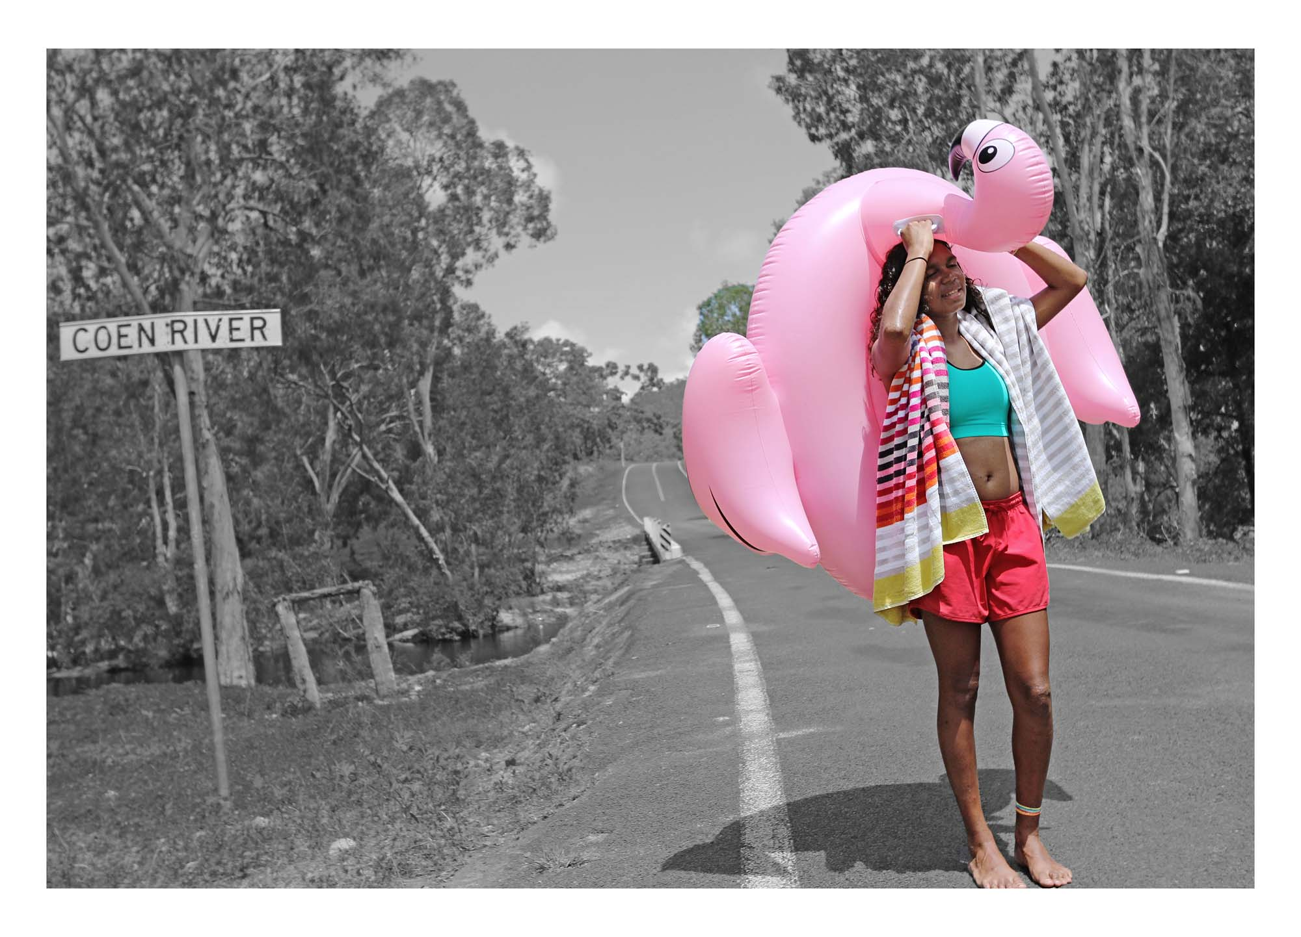
Naomi Hobson: Adolescent Wonderland to tour across regional SA

Today photography needs to push the boundary…I’m using the medium to tell real stories that I feel don’t get told or haven’t been told. I want people to see who our youth really are: fun, playful, smart, savvy, proud, adventurous and witty.
Naomi Hobson

Set to tour across regional South Australia, Naomi Hobson’s series Adolescent Wonderland presents evocative photographic portraits of young Aboriginal people from her community of Coen on Cape York Peninsula. Presented by the Art Gallery of South Australia and Country Arts SA with support from the South Australian Government, the tour will launch in Port Pirie on 11 December 2021 and extend to venues across the state until 8 October 2023.

Naomi Hobson is a Southern Kaantju/Umpila woman who lives in Coen, a small town of 360 people in the centre of Cape York Peninsula in far north Queensland. A multidisciplinary artist, she regularly works across the mediums of painting, ceramics and photography. Inspired by her immediate environment, Hobson’s works express her ongoing connection to Country and her ancestors’ ties and relationships with their traditional lands.

Through her work, first seen by Adelaide audiences in Tarnanthi 2020, Naomi references her family’s political and social engagements as well as her own personal engagement with her Country and community. In the photographic series Adolescent Wonderland, Hobson is working to empower young people in her community, to encourage them to be themselves and to celebrate their uniqueness. Her photographic series allows the viewer to become part of the community and provides an insight into the vulnerability, playfulness and everyday moments of a generation transitioning from teenagers into adults.

The title of this series, Adolescent Wonderland, is inspired by the classic children’s novel Alice’s Adventures in Wonderland by Lewis Carroll. Themes of youth, playfulness and childhood memories are evident in Hobson’s photographs. The brightly coloured figures and their props lure the viewer into a dream-like reality.

As Naomi Hobson says, “I think young people are getting crazy adventurous with all the apps and photo settings in their mobile phones. This is certainly highlighting their personal characters. They’re just really connecting with how they want to share their story ... Young people are so advanced in using technology and they also love getting their photos taken, but let them show you their story, their way; that’s what Adolescent Wonderland is all about.”

Hon. Steven Marshall, MP, Premier of South Australia says, “I’m thrilled that young people in the regions of South Australia will be among the audiences who will have the opportunity to experience the very best of contemporary Aboriginal art.”

AGSA Director Rhana Devenport ONZM says, “With a voracious practice that spans painting, ceramics and photography, Naomi Hobson’s Adolescent Wonderland will transport regional South Australian viewers to witness daily life in the artist’s small hometown of Coen on Queensland’s Cape York Peninsula through these deeply expressive and provocative works.”

Venues across South Australia will also invite their community to participate in a photography competition. Titled Where’s Your Wonderland, the competition invites participants to capture their own everyday worlds for a chance to win. These photographs will also be displayed digitally as part of each touring venue’s exhibition.

This regional South Australian tour is supported by the South Australian Government and presented in partnership with the Art Gallery of South Australia and Country Arts SA. The Adolescent Wonderland series was first commissioned by the Cairns Art Gallery with funding from the Queensland Government through the Arts Queensland Backing Indigenous Arts initiative.

The current, expanded exhibition was initially created for Tarnanthi, Open Hands exhibition in 2020. presented by the Art Gallery of South Australia with Principal Partner BHP and support from the Government of South Australia.

For full details, visit agsa.sa.gov.au.

ENDS

CONTACTS Lindsay Ferris | 0405 046 116 | ferris.lindsay@artgallery.sa.gov.au
Elisabeth Alexander | 08 8207 7402 | alexander.elisabeth@artgallery.sa.gov.au

TOUR DATES Port Pirie Regional Art Gallery | 11 Dec 2021 – 27 Feb 2022
Port Augusta Yarta Purtli Gallery | 15 April – 5 June 2022
Nautilus Arts Centre | 10 June – 24 July 2022
Roxbylink Art Gallery | 29 July – 18 Sept 2022
Signal Point Gallery | 23 Sept – 13 Nov 2022
Riddoch Art Gallery | 18 Nov 2022 – 15 Jan 2023
Naracoorte Regional Art Gallery | 20 Jan – 26 Feb 2023
The Walkway Gallery | 3 March – 23 April 2023
Murray Bridge Regional Gallery | 28 April – 18 June 2023
Burra Regional Art Gallery | 23 June – 30 July 2023
The Hahndorf Academy | 1 Sept – 8 Oct 2023

SOCIAL MEDIA @agsa.adelaide | @countryarts_sa | #tarnanthi | @tarnanthi
IMAGES XXX

ABOUT NAOMI HOBSON (bio from Tarnanthi 2020 catalogue – update?)
Naomi Hobson is a Southern Kaantju/Umpila woman who lives in Coen, Queensland. Hobson has been a finalist three times in the Telstra National Aboriginal and Torres Strait Islander Art Awards, in 2014, 2015 and 2016, and winner of The Alice Prize in 2016. She is represented in most state collections, including Queensland Art Gallery and Gallery of Modern Art, National Gallery of Victoria, National Gallery of Australia, Art Gallery of South Australia and Museum and Art Gallery of the Northern Territory.

Image caption: Naomi Hobson, Southern Kaantju/Umpila people, Queensland, born Coen, Queensland 1978, OMG! “OMG! This is actually heavier than it looks!” Alaina. from the series Adolescent Wonderland, 2019, Coen, Queensland, digital print on paper, 81.0 x 110.0 cm, Courtesy the artist and Redot Fine Art Gallery, © Naomi Hobson/Redot Fine Art Gallery.

