START AT HOME #69
Contemporary Contact Sheets

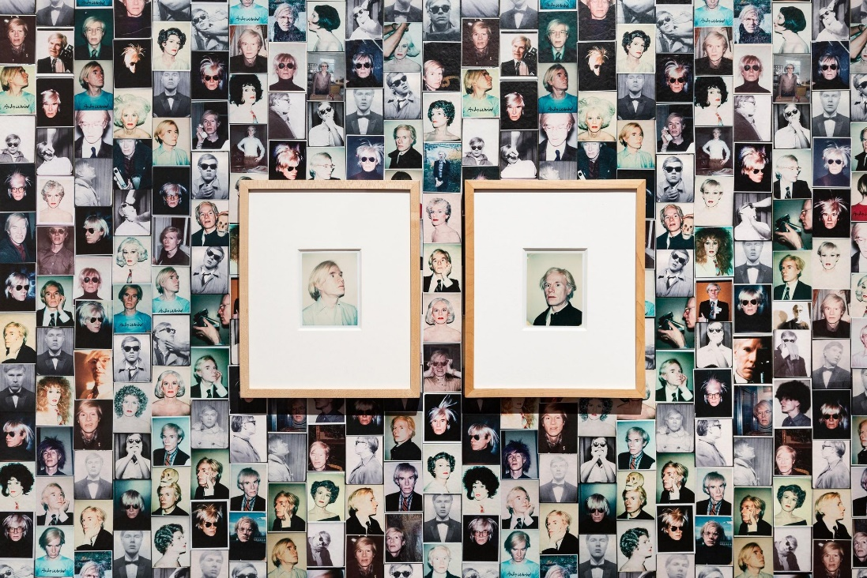
Installation view: Andy Warhol and Photography: A Social Media featuring Andy Warhol’s Self-portraits, Art Gallery of South Australia, Adelaide; photo: Saul Steed

About the artist
Andy Warhol (1928-1987) was an American artist, commonly associated with the Pop Art movement which emerged in the 1950s in Britain and America.
Decades before social media existed, Warhol’s photography was candid, collaborative, and social, attuned to the power of the image to shape his public persona and self-image. Many of his photographs from the 1970s and 1980s offer behind-the-scenes glimpses into his own life and the lives of friends and celebrities such as Muhammad Ali, Bob Dylan, Debbie Harry, Mick Jagger, John Lennon, Liza Minnelli, Lou Reed and Elizabeth Taylor.

What is a Contact Sheet?
In film (or wet) photography, contact sheets are made by placing the negative strips directly onto photographic paper to make one print. This way, the photographer can see all the frames from one roll of film at once. Today, in most smart phones, when scrolling through our images, we see lots of images at once – this could be considered a contemporary version of a contact sheet. Warhol’s contact sheets reveal his daily journeys, the people he meets, and his wry observations of details from everyday life, including shop windows, signage and roadside rubbish. Warhol’s eye was also drawn to serial imagery and abstract patterns, including things such as a shadow on a sidewalk. The images he was collecting through photography were often later reworked for his proposed ‘stitched’ photographs.

Activity Contemporary Contact Sheets
Instructions
- Go for a walk around your home, garden or local area selecting an object or scene to be photographed.
- Scroll through your images on your phone, minimise your view so that you can see multiple shots at once. Stop scrolling at points you find interesting and take a screenshot.
- Did you need to delete some images for your contact sheet to have seamless transition from one image to the next?
- Take a screenshot of your contact sheet.
- Does this ‘contact sheet’ reveal a daily journey like Warhol's? Are the images connected in some way – do they tell a story?

Materials

- Mobile phone or digital camera

Take it further
Take a series of photographs with your friends or family doing extraordinary things. Stitch your photographs together to create one collaborative piece. You may like to do this digitally or with printed images, needle and string or thread.

