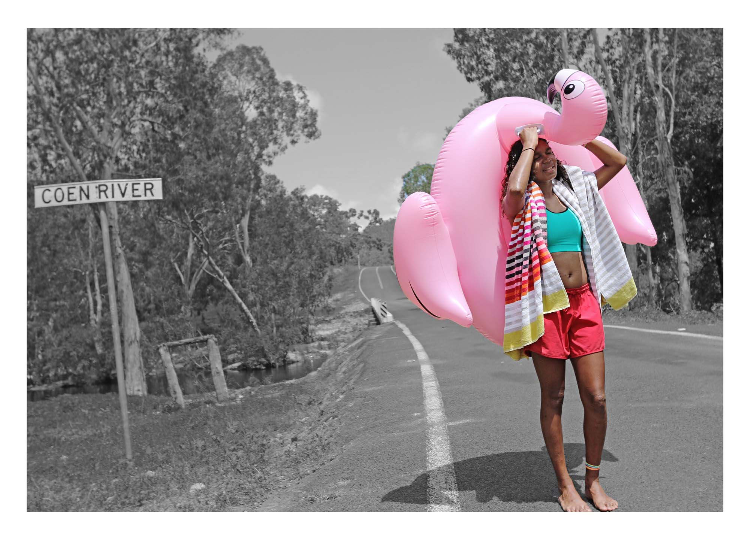
Naomi Hobson: Adolescent Wonderland to open at [insert venue]

Today photography needs to push the boundary…I’m using the medium to tell real stories that I feel don’t get told or haven’t been told. I want people to see who our youth really are: fun, playful, smart, savvy, proud, adventurous and witty.
Naomi Hobson

From [insert date], Naomi Hobson’s evocative photographic series Adolescent Wonderland will be displayed at [insert venue]. Presented by the Art Gallery of South Australia and Country Arts SA with support from the South Australian Government as part of a state-wide regional tour, Adolescent Wonderland depicts young Aboriginal people from Hobson’s community of Coen on Cape York Peninsula.

Naomi Hobson is a Southern Kaantju/Umpila woman who lives in Coen, a small town of 360 people in far north Queensland. A multidisciplinary artist, she regularly works across the mediums of painting, ceramics and photography. Inspired by her immediate environment, Hobson’s works express her ongoing connection to Country and her ancestors’ ties and relationships with their traditional lands.

Through her work, Hobson references her family’s political and social engagements as well as her own personal engagement with her Country and community. In her Adolescent Wonderland series, Hobson is working to empower young people, to encourage them to be themselves and to celebrate their uniqueness. Her photographic series allows the viewer to become part of the community and provides an insight into the vulnerability, playfulness and everyday moments of a generation transitioning from teenagers into adults.

The title Adolescent Wonderland is inspired by the classic children’s novel Alice’s Adventures in Wonderland by Lewis Carroll. Themes of youth, playfulness and childhood memories are evident in Hobson’s photographs, where the brightly coloured figures and their props lure the viewer into a dream-like reality.

As Naomi Hobson says, “I think young people are getting crazy adventurous with all the apps and photo settings in their mobile phones. They’re just really connecting with how they want to share their story...Young people are so advanced in using technology and they also love getting their photos taken, but let them show you their story, their way; that’s what Adolescent Wonderland is all about.”

Hon. Steven Marshall, MP, Premier of South Australia says, “I’m thrilled that young people in the regions of South Australia will be among the audiences who will have the opportunity to experience the very best of contemporary Aboriginal art.”

AGSA Director Rhana Devenport ONZM says, “With a voracious practice that spans painting, ceramics and photography, Naomi Hobson’s Adolescent Wonderland will transport regional South Australian viewers to witness daily life in the artist’s small hometown of Coen on Queensland’s Cape York Peninsula through her deeply expressive and provocative works.”

Country Arts SA Chief Executive Anthony Peluso says, “Naomi Hobson has captured those electrifying coming of age moments. These works shine a light on the resilience, vulnerability, humour and playfulness of First Nations young people in regional communities. We are excited to launch her exhibition in Port Pirie and present it at 11 galleries in regional South Australia throughout 2022 and 2023.”
Visitors are also invited to participate in a photography competition, titled Where’s Your Wonderland. The competition encourages participants to capture their own everyday worlds for a chance to win, with the photographs also displayed digitally as part of the exhibition. [Insert additional venue competition details if required]

This regional South Australian tour is supported by the South Australian Government and presented in partnership with the Art Gallery of South Australia and Country Arts SA. The Adolescent Wonderland series was first commissioned by the Cairns Art Gallery with funding from the Queensland Government through the Arts Queensland Backing Indigenous Arts initiative.

The current, expanded exhibition was initially created for the Tarnanthi Open Hands exhibition in 2020, presented by the Art Gallery of South Australia with Principal Partner BHP and support from the Government of South Australia.

Naomi Hobson: Adolescent Wonderland is on display from [insert date] to [insert date] at [insert venue].

For further information, visit [insert venue URL] or countryarts.org.au

ENDS

CONTACTS [Insert media contact details]

TOUR DATES Port Pirie Regional Art Gallery | 11 Dec 2021 – 27 Feb 2022
Port Augusta Yarta Purtli Gallery | 15 April – 5 June 2022
Nautilus Arts Centre | 10 June – 24 July 2022
Roxbylink Art Gallery | 29 July – 18 Sept 2022
Signal Point Gallery | 23 Sept – 13 Nov 2022
Riddoch Art Gallery | 18 Nov 2022 – 15 Jan 2023
Naracoorte Regional Art Gallery | 20 Jan – 26 Feb 2023
The Walkway Gallery | 3 March – 23 April 2023
Murray Bridge Regional Gallery | 28 April – 18 June 2023
Burra Regional Art Gallery | 23 June – 30 July 2023
The Hahndorf Academy | 1 Sept – 8 Oct 2023

SOCIAL MEDIA @agsa.adelaide | @countryarts_sa | #tarnanthi | @tarnanthi
IMAGES
https://files.artgallery.sa.gov.au/ftp/marketing/MEDIA/2021/NaomiHobson_AdolescentWonderland_Images.zip

ABOUT NAOMI HOBSON
Naomi Hobson is a Southern Kaantju/Umpila multi-disciplinary artist who lives in Coen, Cape York Peninsula, Far North Queensland. Hobson has been a finalist three times in the Telstra National Aboriginal and Torres Strait Islander Art Awards, in 2014, 2015 and 2016, and winner of The Alice Prize in 2016. In 2019, Hobson created the series Adolescent Wonderland for Cairns Art Gallery and exhibited the expanded edition at the Art Gallery of South Australia for Tarnanthi, Open Hands exhibition in 2020. Working with the Australian Tapestry Workshop in 2021, Hobson’s painting The Royal Harvest was produced as a tapestry for the Embassy Tapestry Collection on loan to the Australian Embassy to Indonesia, Jakarta. She is represented by Queensland Art Gallery and Gallery of Modern Art, National Gallery of Victoria, National Gallery of Australia, Art Gallery of South Australia, Museum and Art Gallery of the Northern Territory, Museum of Contemporary Art, Bendigo Art Gallery, Shepparton Art Museum and Cairns Art Gallery. Hobson’s work is held in significant public and private collections nationally and internationally.

Image caption: Naomi Hobson, Southern Kaantju/Umpila people, Queensland, born Coen, Queensland 1978, OMG! “OMG! This is actually heavier than it looks!” Alaina. from the series Adolescent Wonderland, 2019, Coen, Queensland, digital print on paper, 81.0 x 110.0 cm, © Naomi Hobson/Redot Fine Art Gallery.

